**Assignment 4.2**

**Question 1:** Java program to display file and subdirectories during a given timestamp

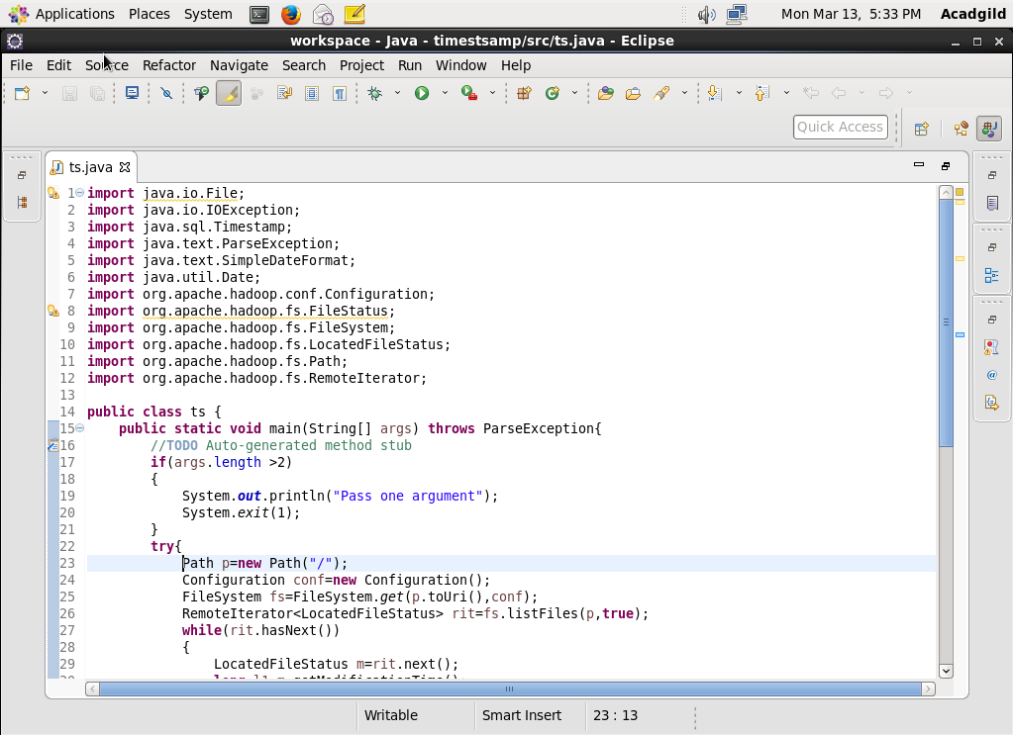

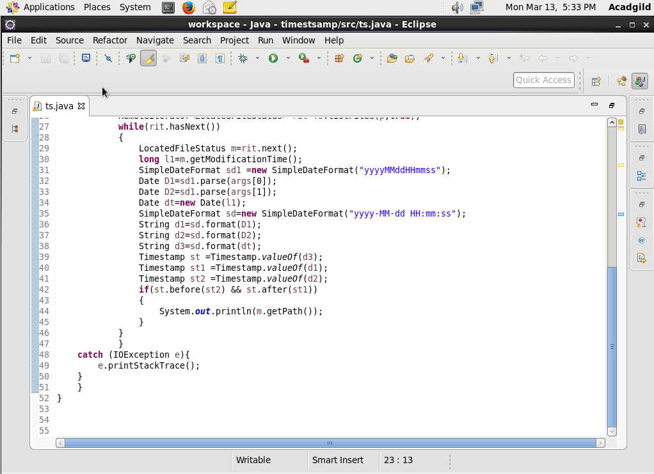

**OUTPUT:**

